Lesson plan 2: Sequencing
About the lesson
This lesson builds on the previous lesson and continues to focus on the key programming construct of sequencing. Students will use the skills they learnt in Lesson 1 but in a more advanced way to create more advanced drawings using the pen function in Scratch. They will then apply this knowledge to a more complex scenario that requires them to sequence a large number of steps to create a drawing.
Learning objectives
By the end of this lesson, students will know how to:
- decompose a complex problem
- use sequencing to solve problems with multiple elements
- construct efficient code by identifying patterns.
National Curriculum
The following subject content from the KS3 National Curriculum is included in this lesson:
- Use two or more programming languages, at least one of which is textual, to solve a variety of computational problems.
Links
There are links to English and the need for precise instructions that are carried out in order. There are also links to maths and the internal angles of shapes.
Key terminology
programming construct, sequencing
Teaching and learning activities
Share the objectives for the lesson with students (Slide 2 of Lesson 2 presentation).
Starter
Ask students to correctly order a series of blocks (Slide 3).
- Students could write the instructions on paper, on a word-processed document, or on a mini whiteboard.
- The idea of the starter is to encourage students to think about the importance of putting instructions in a logical sequence.

Answers
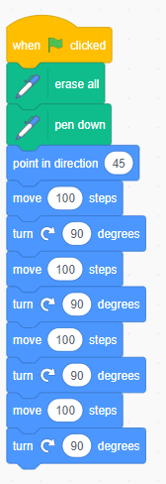
Part 1
Remind students that the three key programming constructs are sequencing, selection and iteration and explain that this lesson will continue to focus on sequencing.
Ask: What could happen if instructions are incorrectly sequenced?
The output would not be the output we wanted.
Ask: Why do we need to use the 'erase all' block?
If we did not use it, the cat would keep drawing new lines and all of the lines drawn before would still be visible.
Ask: Why do we need to use the 'set x to' and 'set y to' blocks?
If we did not use them, each time the program runs, the cat would start from wherever it last finished, and it could end up off the stage.
Ask students to complete Activity 2.1: Drawing a hexagon (Page 44/Worksheet 2.1, plus Evidence document 2 and Slide 4).
There are GIFs in the presentation to show students what should happen when they run their programs. The activity contains two extension activities.
Example answers
(See screenshots below and Activity 2.1 solution)
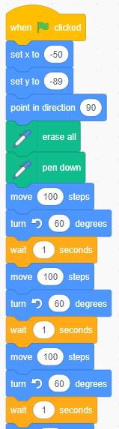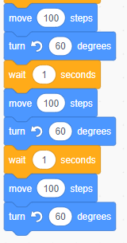

Extension activity 1
(See screenshot below and Activity 2.1 Extension 1 solution)
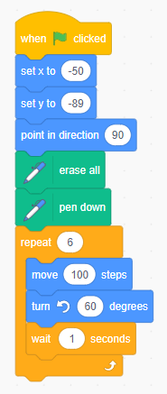

Extension activity 2
(See screenshot below and Activity 2.1 Extension 2 solution)
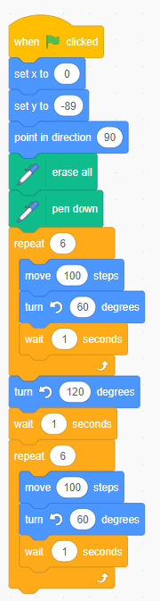

Part 2
Discuss how a complex drawing is made up of many different shapes (Slide 5 and page 45).
You could ask the following questions to facilitate the discussion.
- How many shapes are there in the image?
(Answer: There are five shapes in total [a triangular roof, two square windows, one rectangular door, and one square building] and four unique shapes.)
- Will this drawing be more complex to program than shapes you have previously programmed? Why?/Why not?
(Example answer: It will be more complex because there will be more code, but the skills are not any more complex because it involves using blocks we have already used.)
- What other information do you need to know to be able to draw this image?
(Example answer: The length and width of the different shapes, the angle of the roof and how far the different parts are apart.)
- Which part of the image would you draw first?
(Example answer: There is no right answer, but it makes sense to draw the square building first because three of the other elements sit inside it.)
- What additional block will you need to use?
(Answer: The 'pen up' block so that you can move the cat to its next starting point without drawing a line.)
Ask students to complete Activity 2.2: Creating a picture (Page 45/Worksheet 2.2, plus Evidence document 2 and Slide 6).
- There is a GIF in the presentation to show students what should happen when they run their program.
- You could give further guidance to students that need it, by suggesting they focus on one element of the drawing to start with.
- You could extend the activity for some students by, for example, asking them to add downstairs windows and a garage.
- This activity could be completed as a paired programming task, with students taking it in turns coaching each other to draw one element of the drawing.

Example answers
(See screenshot below and Activity 2.2 solution)

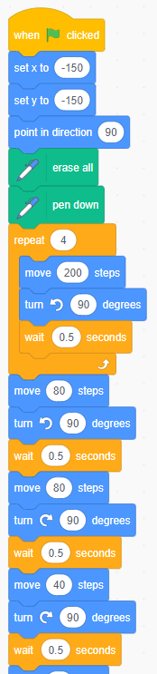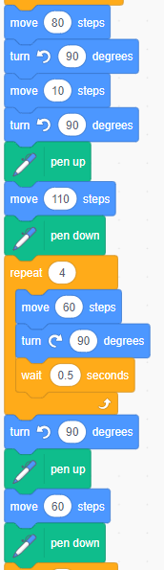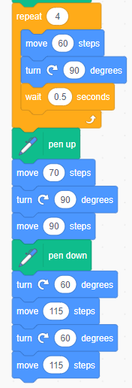

Plenary
Ask students to complete Quiz 2 (Slide 7), to assess their understanding of sequencing and the Scratch environment.
Homework
Ask students to complete any outstanding activities they did not finish during the lesson.
Stretch activities
Some students will complete the activities in this lesson quickly. They could be encouraged to create their own picture using shapes drawn in Scratch. They should explore using iteration to reduce the number of instructions required.
Support activities
Students who struggle to use the correct angles may benefit from increasing the length of the ‘wait’ between each set of blocks, to give them additional time to work out what may be wrong with their code. Drawing the shape onto paper using a pencil, ruler and protractor may help them to understand the angles required, and the steps involved in completing the shape.
When creating the picture of a house they may find it helpful to work with a partner to discuss and write the code together.
A series of videos about drawing shapes in Scratch can be found at: www.youtube.com/channel/UCzyj8fEcs3AFDjMl91PlkxQ.

